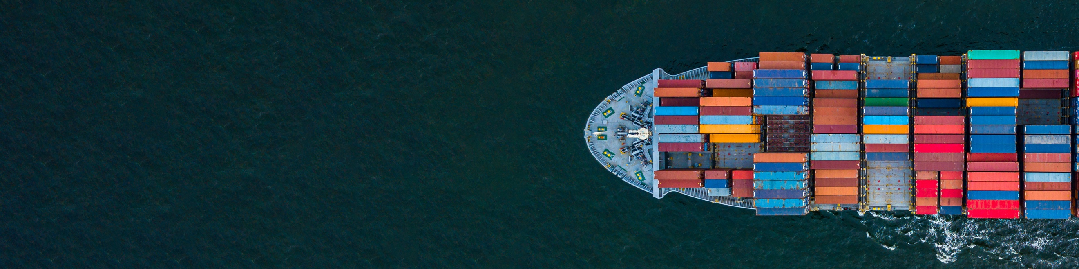

WA WINES TO THE WORLD

PROGRAM PARTICIPANTS

Voyager Estate | Calneggia Family Vineyards
West Cape Howe, Hay Shed Hill | Forest Hill Vineyard
Poacher's Ridge | Corymbia Wine
Plan B Wines | Wills Domain
Singlefile Wines | Ferngrove
Capel Vale Wines | Fraser Gallop Estate
Swings & Roundabouts | Chapman Grove Wines Pty Ltd
Southern Alliance Pty Ltd | Myattsfield Vineyard and Winery
Montys Leap | Jarrah Ridge Wines
Rockcliffe Winery Pty Ltd | Wine Terroirists
Oranje Tractor | Henley Park Wines
Agknowledge | Peccavi Wines
Xanadu. | Churchview Estate & St Johns Vineyards
Miles from Nowhere | St Aidan Wines
Flametree Wines | Wines of Merritt
Vasse Felix | Evoi Wines
Domaine Naturaliste | Oates End
Flying Fish Cove | Redbridge Pty Ltd
Great Southern Wine Producers Association | Gilbert Wines
Marron Creek Wine Co | Leeuwin Estate
Frankland Estate Wines | Silverstream Wines
Willow Bridge Estate | Vineyard 28
Burch Family Wines | Margaret River Wine
3Drops | Fogarty Wine Group
Plantagenet Wines | Lost Lake Wines
Whicher Ridge Wines | Moss Wood Pty Ltd
Galafrey Wines | Dickinson Estate
Barton Jones Wines | Snake and Herring  Cape Mentelle

