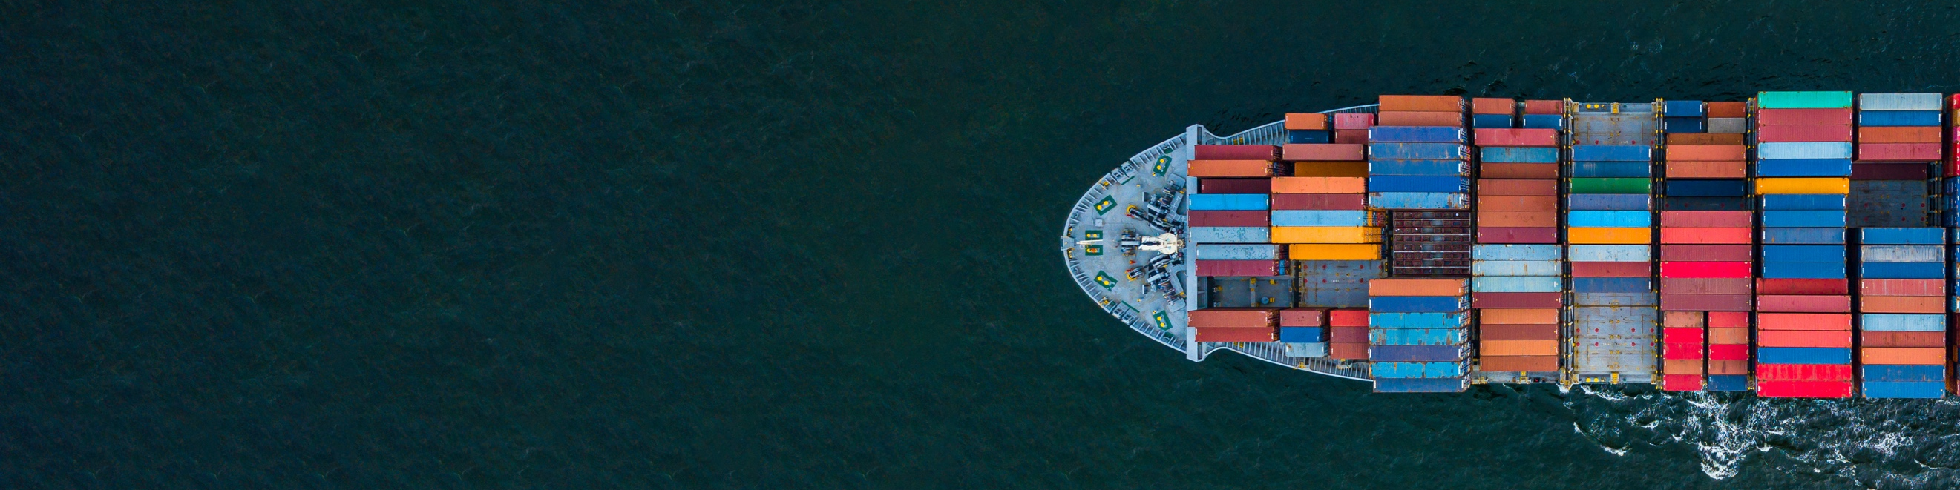

WA WINES TO THE WORLD

PROGRAM PARTICIPANTS (June 2021)

WESTERN AUSTRALIA

Burch Family Wines
Capel Vale Wines
Fogarty Wine Group as above in 10
Plan B Wines
Redbridge Pty Ltd
Snake and Herring
Whicher Ridge Wines

SWAN VALLEY

Corymbia Wine
Henley Park Wines
Jarrah Ridge Wines
Wine Terroirists

PERTH HILLS

Myattsfield Vineyard and Winery

PEMBERTON

Lost Lake Wines

MARGARET RIVER

Calneggia Family Vineyards
Cape Landing Pty Ltd
Cape Mentelle
Chapman Grove Wines Pty Ltd
Churchview Estate & St Johns Vineyards
Domaine Naturaliste
Evoi Wines
Flametree Wines
Flying Fish Cove
Fraser Gallop Estate
Leeuwin Estate
Miles from Nowhere
Moss Wood Pty Ltd
Margaret River Wine Association
Oates Ends
Passel Estate
Peccavi Wines
Small Things Wine
Swings & Roundabouts
Vasse Felix
Voyager Estate
West Cape Howe, Hay Shed Hill
Wills Domain
Wines of Merritt
Xanadu

GREAT SOUTHERN

3Drops
Femgrove
Forest Hill Vineyard
Frankland Estate Wines
Galafrey Wines
gilbert wines
Great Southern Wine Producers Association
Marron Creek Wine Co
Montys Leap
Oranje Tractor
Plantagenet Wines
Poacher's Ridge
Rockcliffe Winery Pty Ltd
Silverstream Wines
Singlefile Wines
Southern Alliance Pty Ltd
West Cape Howe

GEOGRAPHE

Barton Jones Wines
Geographe Wine Industry Association
St Aidan Wines
Vineyard 28
Whicher Ridge Wines

